In the Grocery Cart This Month
For NOVEMBER: We will collect food for Thanksgiving: “cranberry sauce, corn, green beans, yams; jars of gravy, boxed stuffing, and boxed cornbread mix. In the Hygiene room we are in need of body wash for men and women and body lotion. Please feel free to donate any other hygiene products.” Place donations in the grocery cart, located in the Commons. **NOTE: Please put all liquids in the box provided. Tape down all flip top bottles.

Children and Their Safety are Important at Chestnut Hill UMC
We rejoice that as a church we are able to offer carefully planned, age appropriate care and activities for our children and youth.
Today, children ages 6 and above will stay in the sanctuary for worship.
The Nursery for infants up to age 6 is located in Classroom 101 (exit through the right side door at the front of the sanctuary, pass through “the Commons,” go through the double doors to the Education Building and follow the hallway to the
Nursery at the end of the hall on the left).

DIRECTORY OF CHESTNUT HILL UNITED METHODIST CHURCH
 | Sharma Lewis | Richmond Area Resident Bishop
 | Scott Davis | Lynchburg District Superintendent
 | Liz Ecklund | Minister
 | Vernie Barrow | Minister Emeritus
 | Monica Campbell | Administrative Assistant
 | Heather Wilson | Director of Music Ministry
 | Judy Martin | Bookkeeper
 | Judy Robertson | Lay Leader
 | Erin Ecklund | Nursery Supervisor


Chestnut Hill
United Methodist Church

Making disciples of Jesus Christ
for the transformation of the world.
You are welcome at Chestnut Hill UMC.

4660 Fort Avenue ~ Lynchburg, Virginia 24502
Church: 434-239-8423
Pastor’s Cell: 434-258-2934; Pastor’s Home: 434-319-5646
Email Pastor Liz: Pastorliz@aol.com
chestnuthillumc@comcast.net ~ on the web at chestnuthillumc.net
Find us on Facebook: Chestnut Hill United Methodist Church
Chestnut Hill United Methodist Church
10:30 a.m. ~ November 17, 2019 ~ Twenty-third Sunday after Pentecost
Our ministry vision for the Virginia Annual Conference is “to be disciples of Jesus Christ who are lifelong learners, who influence others to serve.”
Welcome! Join us in worshiping God!
Welcome and Ministry Announcements
Welcome in the name of Christ our Lord. Please register your attendance,
printing your name, address, phone, and email, when the pew pad is passed to you.
Thank you for silencing cell phones as we gather to worship God.
Invocation
Prelude “Holy, Holy, Holy” arr. Hayes
Call to Worship
Let all who await the return of Christ unite today in worship.
For Christ is the Lord of history; all nations will bow before God.
Yet Christ is also the Lord of our hearts and knows each of us well.
For the faithful, the final return of the Lord will bring victory.
And for all who love the Christ there will be eternal life.
Blessed be the name of the Lord!
*Singing Our Faith # 733 “Marching to Zion”
Morning Prayer
Almighty and righteous God, be our strength, our courage, and our salvation in the face of all the world might do to silence the message of Your wonderful Good News. In Christ we pray. Amen.
Prayer of Confession
Words of Assurance
Be glad and rejoice forever in what God is creating. We are a joy and a delight to God. Amen
Choral Anthem “Still the Lord of All” Larson

Prayer for Illumination Linda Jessen
Lord, open our hearts and minds by the power of your Holy Spirit, that, as the Scriptures are read and your Word proclaimed, we may hear with joy what you say to us today. Amen.
New Testament Lesson I Thessalonians 3:6-13 (CEB) Linda Jessen
Gospel Lesson Luke 21:5-19 (CEB) Linda Jessen
The Word of God for the people of God.
Thanks be to God.
Singing Our Faith # 377 “It Is Well with My Soul”
The Good News “Tough Times”
The Giving of God’s Tithes and Our Gifts
Prayer of Thanksgiving
Offertory “Now Thank We All Our God” arr. Boesiger
*Doxology # 95 Praise God from whom all blessings flow; praise him, all
Creatures here below; praise him above, ye heavenly host; praise Father, Son, and Holy Ghost. Amen.
The Prayers of the People
The Lord’s Prayer
Our Father, who art in heaven, hallowed be thy name. Thy kingdom come,
Thy will be done on earth as it is in heaven. Give us this day our daily bread and forgive us our trespasses, as we forgive those who trespass against us. And lead us not into temptation, but deliver us from evil. For thine is the kingdom, and the power, and the glory, forever. Amen.
*Singing Our Faith # 430 “O Master, Let Me Walk with Thee”
*Blessing and Dismissal
*Postlude
Scatter to Serve God & Neighbor
Welcome to all! We gather to praise God for the innumerable blessings given to us and to grow deeper in the Spirit. Joyfully, let us lift our hearts to God.

**This Week’s Calendar**

Sunday, 11/17 | 2:00 p.m. | PEO Organization of Women  There will be a sale (and tasting) of Tastefully Simple products in our fellowship hall this afternoon from 2:00 - 4:00 to benefit PEO (Philanthropic Educational Organization), to which Neta, Susan Beasley (Pat's daughter), and Judy Robertson belong. Anyone is welcome to come. These products are seasonings, dip mixes, soup mixes, etc. Come and taste and maybe do some Christmas shopping!
 | 3:00 p.m. | Cantata Rehearsal @ Timberlake UMC
Tuesday, 11/19 | 9:00 a.m. | Prayer Group
 | 10:00 a.m. | Homeschool First
 | 10:30 a.m. | Bible Study
 | 1:00 p.m. | Homeschool First Game Day
Wednesday, 11/20 | 11:00 a.m. | Top of the Hill  Deneen Safritt and Dana Ballard will present a program of Thanksgiving and Christmas music. Bring a sandwich. Dessert and drinks will be provided.
Thursday, 11/21 | 6:00 p.m. | Handbells
 | 6:45 p.m. | Choir
Friday, 11/22 | 9:00 a.m. | Homeschool First
** Looking Ahead on the Calendar **
Saturday, 11/30 | 10:00 a.m. | Decorating of Church  Helpers greatly appreciated. For more information contact Judy Robertson.
Sunday, 12/8 | 11:45 a.m. | Chestnut Hill UMC Annual Christmas Lunch

2019 Christmas Angel Tree Program
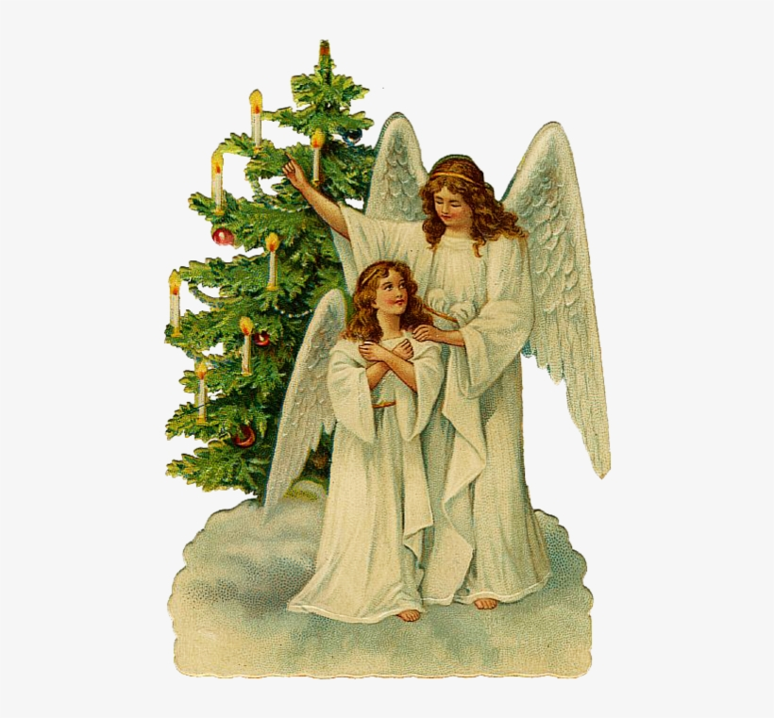
Angels will be available to “pick” from the Angel Tree TODAY! This year, you may shop for the child as usual, or you may give whatever amount of money you would spend on the child in the form of a check payable to CHUMC with the name of your angel written on the check. Then all money will be turned over to Humankind on Wednesday, December 4 so that their staff can shop for your child. They will return the gifts to us on December 13 so that the women of the church can wrap/gift bag them at the UMW luncheon on December 14. If you are giving money rather than shopping, please turn it in to church by Sunday, December 1.
IMPORTANT: If you are SHOPPING for your angel, have all gifts returned to the church NO LATER than Thursday, December 12th!
There will be a sheet by the Angel Tree to sign up what angel you have taken and whether you are shopping or giving money.
Humankind is depending on us to be the major provider of Christmas for these children, so thank you so much for your generosity!
~Judy Robertson
Read Ahead
November 24, 2019 ~Christ the King/Thanksgiving Sunday. The Scriptures are Jeremiah 23:1-6 & Canticle: Luke 1:68-79 ~ UMH #208. The sermon text is Luke 23:33-43 and the message is “Gifts”.

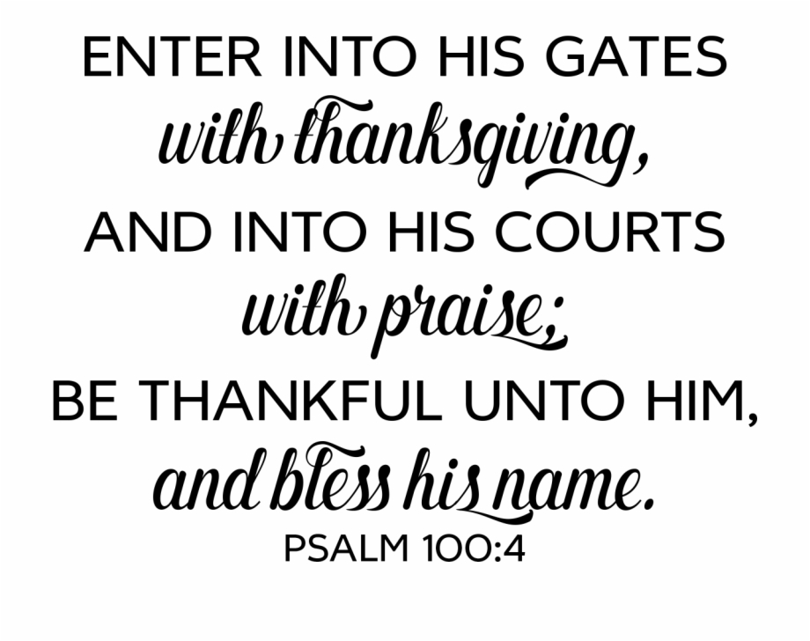

**This Week’s Calendar**

Sunday, 11/17 | 2:00 p.m. | PEO Organization of Women  There will be a sale (and tasting) of Tastefully Simple products in our fellowship hall this afternoon from 2:00 - 4:00 to benefit PEO (Philanthropic Educational Organization), to which Neta, Susan Beasley (Pat's daughter), and Judy Robertson belong. Anyone is welcome to come. These products are seasonings, dip mixes, soup mixes, etc. Come and taste and maybe do some Christmas shopping!
 | 3:00 p.m. | Cantata Rehearsal @ Timberlake UMC
Tuesday, 11/19 | 9:00 a.m. | Prayer Group
 | 10:00 a.m. | Homeschool First
 | 10:30 a.m. | Bible Study
 | 1:00 p.m. | Homeschool First Game Day
Wednesday, 11/20 | 11:00 a.m. | Top of the Hill  Deneen Safritt and Dana Ballard will present a program of Thanksgiving and Christmas music. Bring a sandwich. Dessert and drinks will be provided.
Thursday, 11/21 | 6:00 p.m. | Handbells
 | 6:45 p.m. | Choir
Friday, 11/22 | 9:00 a.m. | Homeschool First
** Looking Ahead on the Calendar **
Saturday, 11/30 | 10:00 a.m. | Decorating of Church  Helpers greatly appreciated. For more information contact Judy Robertson.
Sunday, 12/8 | 11:45 a.m. | Chestnut Hill UMC Annual Christmas Lunch

2019 Christmas Angel Tree Program
Angels will be available to “pick” from the Angel Tree TODAY! This year, you may shop for the child as usual, or you may give whatever amount of money you would spend on the child in the form of a check payable to CHUMC with the name of your angel written on the check. Then all money will be turned over to Humankind on Wednesday, December 4 so that their staff can shop for your child. They will return the gifts to us on December 13 so that the women of the church can wrap/gift bag them at the UMW luncheon on December 14. If you are giving money rather than shopping, please turn it in to church by Sunday, December 1.
IMPORTANT: If you are SHOPPING for your angel, have all gifts returned to the church NO LATER than Thursday, December 12th!
There will be a sheet by the Angel Tree to sign up what angel you have taken and whether you are shopping or giving money.
Humankind is depending on us to be the major provider of Christmas for these children, so thank you so much for your generosity!
~Judy Robertson
Read Ahead
November 24, 2019 ~Christ the King/Thanksgiving Sunday. The Scriptures are Jeremiah 23:1-6 & Canticle: Luke 1:68-79 ~ UMH #208. The sermon text is Luke 23:33-43 and the message is “Gifts”.

